EARLY WARNING BULLETIN FOR FOOD SECURITY

No. 2014/14 IN THE GAMBIA Period: September 11-20, 2015

 Government of The Gambia | Produced and Published by The Gambia National Multidisciplinary Working Group  Focal Point: Department of Water Resources  TEL: (+220) 4227631 / 4224122 / 8905229 - FAX: (+220) 422 50 09  E-MAIL: dwr@mofwrnam.gov.gm / WEB: www.mofwrnam.gov.gm | 

1.0 METEOROLOGICAL SITUATION

1.1. SYNOPTIC SITUATION

The average surface position of the ITD oscillated over southern Mauritania, central Mali onto central Niger.

Dry and stable atmosphere prevailed to the north of the ITD with dust haze patches observed over southern Mauritania. On the other hand, convective activities prevailed to the entire south of the ITD during the dekad resulting to the rains and thunderstorms experienced over the Gambia.

1.2 WEATHER SUMMARY FOR THE GAMBIA

Variably cloudy and humid atmosphere prevailed with thunderstorms and rain during the dekad.

1.3 WEATHER OUTLOOK FOR THE NEXT DEKAD (21st – 30th September 2015)

Variably cloudy and humid atmosphere is expected to prevail with thunderstorms and rain.

2.0 AGROMETEOROLOGICAL SITUATION

2.1 RAINFALL SITUATION

The rainfall situation continued in this dekad as the previous dekads of September and August across the country; however the recorded dekadal totals showed big variations in some stations. In the Western Third, dekadal totals varied from 105.3mm and 105.5mm (highest) over Yundum Airport and Banjul respective to 46.9mm over Kerewan. In the Middle Third dekadal totals varied between 107.8mm (highest) over Jenoi to 12mm over Janjanbureh. In the Eastern Third dekadal totals were 47.7mm and 41.7mm over Basse and Fatoto respectively. (Figure 1a). This showed that much of the rains were recorded around the coastal zones.

Seasonal rainfall amounts recorded as of 20th September also indicates big variations in rainfall amounts over various regions with the Western Third leading by a high margin. In the Western Third seasonal totals varied from 1149.3mm (highest) countrywide over Yundum Airport to 585.3mm over Banjul. In the Middle Third, Sapu recorded the highest of 1012.7mm; while Kaur recorded the lowest seasonal total of 465.8mm, lowest countrywide. In the Eastern Third, Basse and Fatoto recorded 775.5mm and 713.2mm respectively (Figure1b).

The Table below shows highest daily down pours during the dekad. Three stations (red coloured) recorded rainfall figures that can have potential impacts on Agriculture and settlements by causing flash floods, washing away soil nutrients, and also newly transplanted seedlings.

Table 1: Highest daily downpours per station during the dekad

WESTERN THIRD
Station |  |  | Rainfall in Millimeters | Date
Yundum Airport |  |  | 49.2 | 15th /09/2015
Banjul |  |  | 56.5 | 20th /09/2015
Sibanor |  |  | 29.5 | 13th /09/2015
Kerewan |  |  | 22.1 | 15th/09/2015
MIDDLE THIRD
Jenoi |  |  | 77.7 | 15th/09/2015
Kaur |  |  | 18.5 | 12th /09/2015
Sapu |  |  | 25.0 | 12th/09/2015
Janjanbureh |  | 10.0 |  | 16th/09/2015
EASTERN THIRD
Basse | 28.4 |  |  |  | 15th /09/2015
Fatoto | 34.8 |  |  |  | 15th/09/2015

Figure 1a: Rainfall dekadal totals 11th –20th September 2015.

Figure 1b: Rainfall Seasonal totals from May 1st 2015 – September20th 2015.

2.2 RAINFALL COMPARISMS

The Country average as of 20th September 2015, stand at 785.5mm, 42.5% above the country average of last year (20th September 2014, 550.9mm), and 6% above the long term mean (1981-2010) 740.7mm.

2.3 Temperature

Average temperatures across the country varied between 25ºC and 28ºC. Maximum temperatures were between 34⁰C and 35⁰C over the entire country excepting. Only Sibanor in the Western Third recorded 38°C. Minimum temperatures varied between 22ºC and 25°C countrywide.

2.4 Winds

Winds were light, moderate in the Middle Third and to a maximum speed of 55.4km/h in the Western and Eastern Thirds of the country.

2.5 Sunshine Duration

Sunshine duration on average in this dekad was 2hours in the Eastern Third to a maximum of 7hours in the Western Third of the country.

2.6 Relative Humidity

Average relative humidity across the country continued to be high over 70% on average across the country. This shows there is still enough moisture content in the atmosphere favourable for further rains.

3.0 Hydrological Situation

These information was recorded from the 04/09/2015 to 22/09/2015 time period and was downloaded during our last monthly data collection exercise from the 17th - 22nd September, 2015
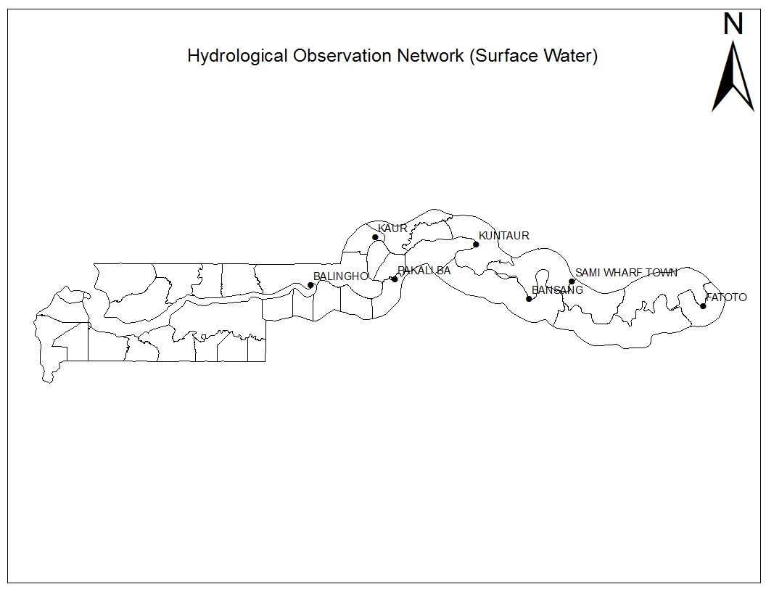
Max: 1.64m
Min: 0.37m
Sal: Nil

Max: 2.57m
Min: 1.70m
Sal: Nil
Max: 2.02m
Min: 1.06m
Sal: Nil
Max: 1.59m
Min: 1.03m
Sal: Nil
Max: 3.22m
Min: 2.67m
Sal: Nil

The river has burst its banks
Basse:
The river has equally burst its banks
Tendaba:
Max: 1.79m
Min: 0.14m
Sal: Nil
Fig 2; the map of the Gambia showing the Hydrological Observation Network

The high water levels still persist in most of the water level stations with the river bursting its banks at Fatoto and Basse thereby hampering the ferry services in those points.

On the salinity front, all the stations that lie within the seasonally saline region (i.e. Kaur, Pakaliba, Ballingho and Tendaba) are all free from salinity.

4.0 AGRICULTURAL SITUATION

WEST COAST REGION

N/A

NORTH BANK REGION

Agricultural activities in this region involves rice transplanting in the lowland fields that is at finishing touches, weeding in the upland fields, planting of some water melon and cowpea is still in progress in some areas. Phenologically most crops are at reproductive phase. However, there were reports of Blister beetles in Sabach Sanjal and some worms were also spotted in the Upper and Lower Baddibu districts of the Region, but were not significant.

LOWER RIVER REGION

Agricultural activities in this region are mainly planting of swamp rice and some water melon, weeding is still a problem due to continued rains that favours the growth of weeds and reducing working hours on the farms. Backyard maize is being harvested, while most other crops are at reproductive phases (upland rice is at panicle initiation, groundnut is pegging, cowpea is at pod formation, early millet is at grain formation).

CENTRAL RIVER REGION NORTH

Weeding on watermelon and sesame fields is still ongoing, rice transplanting in Tidal fields at Wassu is also ongoing. Crop phenology varies; sorghum is at vegetative stage, while most other crops are at reproductive stages. However, there was flooding in this Region that washed away transplanted seedlings and farmers has to wait for the water to recede before they can retransplant.There were pest attacks (Army Worms) in the rice fields at Banni but were controlled by the Agricultural staff on the ground.

CENTRAL RIVER REGION SOUTH

In this Region, ploughing and transplanting is going on in both the Lowlands and Tidal areas, whereas in the Pump Perimeters, ploughing, harvesting, threshing, ploughing and transplanting is all going concurrently on the rice fields. In the Upland fields, some farmers are involved in weeding and sowing of sesame and watermelon, while others are harvesting maize. There is also bird scaring on early millet fields. However, Hippos and Monkeys are major threats to farmlands in this region.

UPPER RIVER REGION

Agricultural activity in this region is planting of watermelon and weeding on some fields which is also a major problem like in other Regions. Crop phonological stages vary but most crops are at their reproductive stage.

4.1 COMMODITY PRICES
N/A

4.2 CROP PROTECTION
N/A
4.3 DEPARTMENT OF LIVESTOCK SERVICES
N/A

4.4 FISHERIES
N/A

5.0 NATIONAL DISASTER MANAGEMENT AGENCY (NDMA)
N/A

6.0 NATIONAL ENVIRONMENT AGENCY (NEA)
N/A

Banjul September 21st 2015
National MWG of The Gambia

Composition of MWG:  Department of Water Resources  Planning Services - Department of Agriculture (DOA)  Communication, Extension & Education Services - DOA  Department of Livestock Services  Plant Protection Services - DOA  National Environment Agency | Direct your comments and questions to:  The Director  Department of Water Resources  7 Marina Parade, Banjul  The Gambia  Tel: (+ 220) 422 76 31 / 422 41 22 / 890 52 29  Email: dwr@mofwrnam.gov.gm

